1 a) Left-most derivation
(* ( car (2 4 ( + 2 4 ) 8 ) ) ( / 27 9) );
Lisp -> ( * num num );
- ( * ( car ( list ) ) num ) );
- ( * ( car ( seq ) ) num ) );
- ( * ( car ( seq num ) ) num ) );
- ( * ( car ( seq num num ) ) num ) );
- ( * ( car ( num num num ) ) num ) );
- ( * ( car ( num num num num ) ) num ) );
- ( * ( car ( 2 num num num ) ) num ) );
- ( * ( car ( 2 4 num num ) ) num ) );
- ( * ( car ( 2 4 ( + num num ) ) num ) );
- ( * ( car ( 2 4 ( + 2 num ) ) num ) );
- ( * ( car ( 2 4 ( + 2 4 ) num ) ) num ) );
- ( * ( car ( 2 4 ( + 2 4 ) 8 ) ) num ) );
- ( * ( car ( 2 4 ( + 2 4 ) 8 ) ) ( / num num) );
- (* ( car ( 2 4 ( + 2 4 ) 8 ) ) ( / 27 num) );
- ( * ( car ( 2 4 ( + 2 4 ) 8 ) ) ( / 27 9) );

1 b) Parse tree ( * ( car ( 2 4 ( + 2 4 ) 8 ) ) ( / 27 9) );
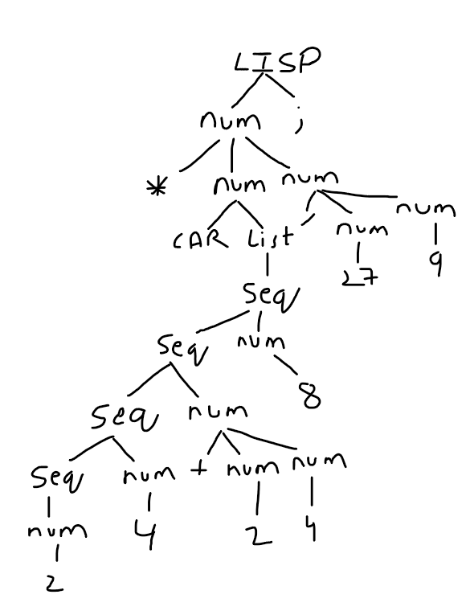
2) program -> relation COLON HYPEN relationList PERIOD
Name -> letter | Letters
VarName -> letter | Letters | number
varList -> varName COMMA varList
relation -> name LPAREN VarName RPAREN
relationList -> relation
relationList -> relation COMMA relationList PERIOD.
3) In this case INT is the token for ‘int’, terminal tokens are caps and non terminals are lowercase/came|case) start -> assignment SEMI

varName -> letter | letters | letters numbers
intDec -> varName
intDec -> INT varName
intDec -> varName EQUALS NUMBER
intDec -> INT varName EQUALS NUMBER
intDec -> INT varList EQUALS NUMBER

varList -> intDec
varList -> intDec COMMA varList

numList -> NUMBER
numList -> NUMBER COMMA numList

intArray -> INT LSBRACKET RSBRACKET varName EQUALS varName
intArray -> INT LSBRACKET RSBRACKET VARNAME EQUALS VARLIST
intArray -> INT LSBRACKET RSBRACKET varName EQUALS numList
intArray -> INT LSBRACKET RSBRACKET varName EQUALS LSBRACKET numList RSBRACKET
intArray -> INT LSBRACKET RSBRACKET varName EQUALS LSBRACKET varList RSBRACKET
assignment -> intDec SEMI
assignment -> intArray SEMI

4) Language is:- a ‘s appear before b
-b’s appears before c
- the strings are like aaabbbccc, aabbcc, abc
Step- write grammer for this language
Context-free-grammer- the cgf is a formal type grammer. It is a set of rules those rules are production rules that decribes all possible strings in a given language.
- Production rules are simple replacements
A-> α ||replace A with α
S -> absc | B
B -> bBc | λ
-non terminal symbols are Sβ
- terminal symbols are a,b,c,λ
-production rules are
S-> abSc|B
B->bBs|λ
- abc
S-> abSc
abBc (S->B )
abλc ( B-> λ)
abc
- abbcc
S->abSc
abSc( S-> B )
abbBcc ( B_> bBc)
abbλcc (B-> λ)
abbcc
Step 2: attribute grammer defined context free grammer.
Attribute grammer are two type
- Synthesized attributes
- Inherited attributes
Context free grammer
<letter sequence> :: =<a sequence> <b sequence> <c sequence>
< a sequence>:: = a | <a sequence> a
<b sequence> :: =b |<b sequence> b
<c sequence > ::= c| <c sequence> c
Parse tree:-
5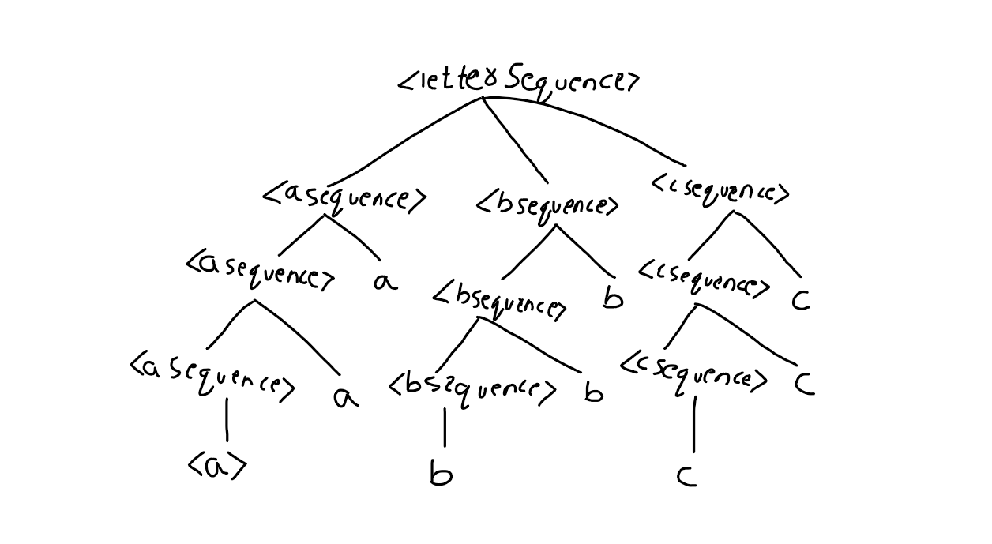

5) btree : NIL |LPAREN btree COMMA value COMMA btree RPAREN
Value: digit | digit Value
digit: 0|1|2|3|4|5|6|7|8|9
some examples of binary tree are
(NIL, 12 NIL)
((NIL,12,NIL),20,(NIL,15,NIL))
((NIL,3,NIL),8,((NIL,12,NIL),20,(NIL,15,NIL)))
Let , btree-> S
Value -> V
Digit -> D
LPAREN -> L
COMMA -> ;
RPAREN-> r
Let,
S-> NIL|ls,v,Sr
V-> D|DV
D-> 0|1|2|3|4|5|6|7|8|9
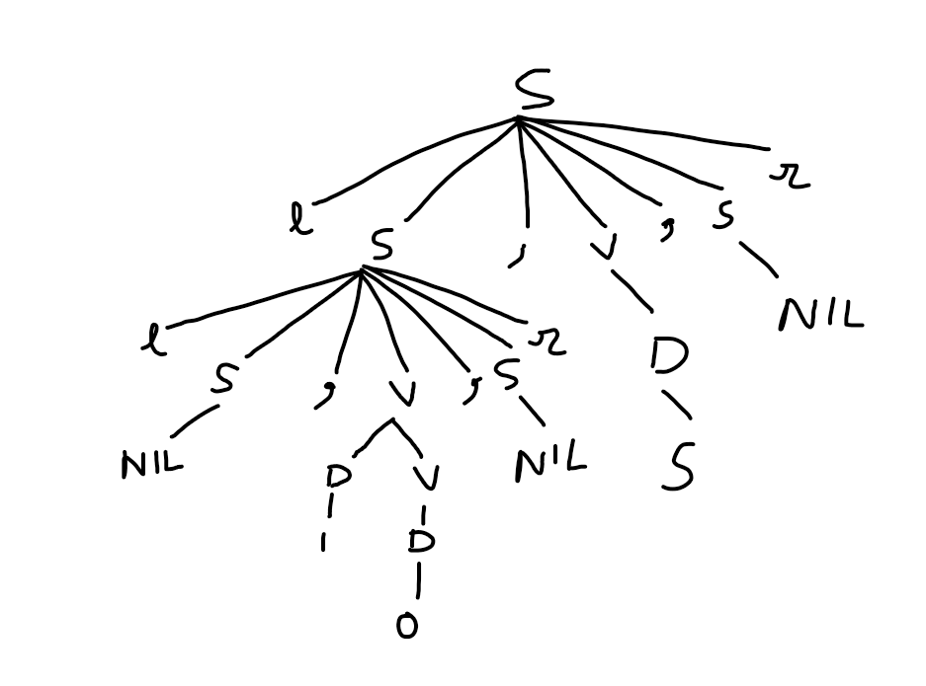
((NIL,10,NIL),5,NIL)
So the above tree balanced because the heights of the subtrees at each interrior node are within one of each other.
6) bool : boolExpr
bool: leftExpr bop rightExpr
: var bop var
But from give question var can be boolean value that can be ‘1’ or ‘0’.
So var 1|0
boolExpr: Var bop Var var can be 1 0, 0 1, 1 1, 0 0.
:1 AND 1
:1
And, here’AND’ is for multiplication if both are true then the AND statement is also TRUE then the AND statement is also TRUW. Here TRUE can be created as ‘1’. Here FALSE can be created as ‘0’ then for bool: boolExpr
bool: left Expr bop rightExpr
:var bop Var
:var OR var
:1 OR 1
bool:0
there, OR defined if one statement is TRUE then OR statemtn will be TRUE otherwise FALSE.
bool: boolExpr
:NOT leftExpr
:NOT var
:NOT 1 ( NOT is negation)
: ~ 1 (if Var is ‘0’ then the
: 0 boolvalue will be 1).

